66 Science & technology The Economist July 11th 2020

Climate change

**Delayed cool**

# Emissions slashed today will be felt only in the middle of the century

Much of the international eﬀort thus

compounded by these kinds of natural ef- fects. As emissions begin to drop, natural variability will also mask any slowdown of global warming that results. Dr Samset’s modelling took this into account.

In addition, more than 90% of the ener- gy trapped by the greenhouse-gas emis- sions produced in the past half-century has been stored in the ocean and released to the atmosphere as heat only slowly. Even if all emissions were cut tomorrow, that process

far to combat climate change has fo- cused on cutting emissions of greenhouse gases, chief among them carbon dioxide. That is, of course, a rational approach. Glo-

# The long game

Pollutants, year in which there is a statistically significant deviation in global temperature trends*, if emissions were reduced now

would continue to warm the air above for many years to come.

The main reason for the delay, however, is that carbon dioxide emitted today will

bal average temperatures are roughly 1.1°C

Zero-emissions scenario

5% decrease per year

remain in the atmosphere for decades to

warmer today than in pre-industrial times and CO2 is the main culprit. It and other greenhouse gases are produced when fossil fuels are burned to generate energy or pow- er engines, in steel and cement-making, by farming and deforestation. In the long term, eliminating these emissions is the only sustainable solution for stopping the inexorable warming of the planet.

But greenhouse-gas emissions do not

2020

Carbon dioxide Black carbon Methane

Nitrous oxide

*Compared to RCP4.5

2040

2060

2080

centuries before it is reabsorbed by vegeta- tion and the oceans. That is not true of oth- er industrial emissions. Each molecule of methane warms the planet 84-87 times more, averaged over 20 years, than carbon dioxide, but it stays aloft for merely years instead of decades or centuries. This has resulted in calls for immediate action to slash methane emissions, for instance by plugging leaks in natural-gas infrastruc-

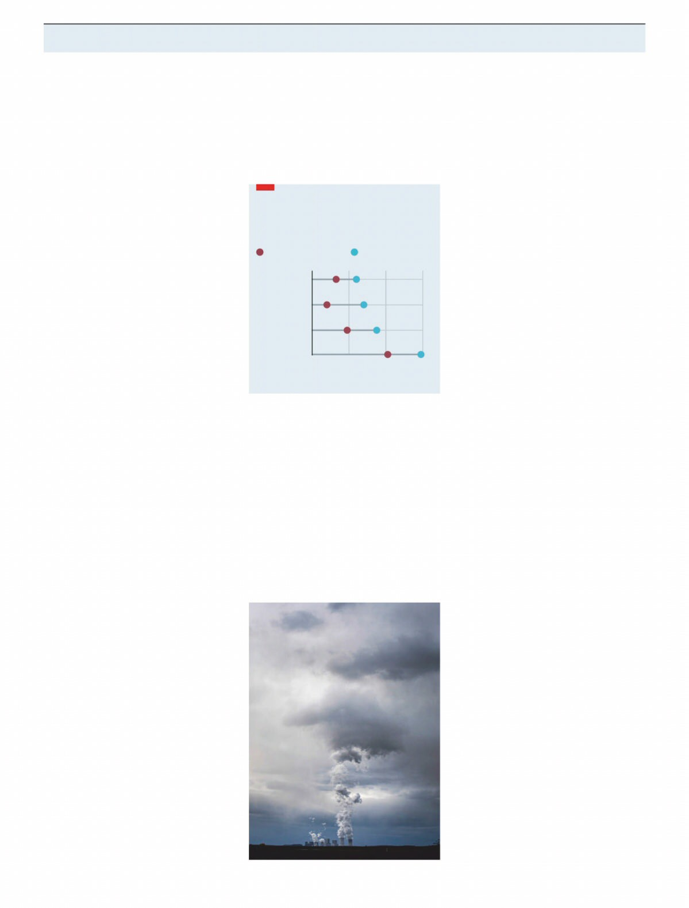cause an instantaneous rise in global tem- peratures, and neither does cutting them result in instantaneous cooling. Instead, it will take decades for today’s policy eﬀorts to result in measurable impacts on global temperature—as illustrated in a study pub- lished this week in *Nature Communications*. Using climate models, Bjorn Samset and his colleagues at Norway’s Centre for International Climate Research probed hy- pothetical futures in which emissions of nine diﬀerent industrial pollutants, in- cluding carbon dioxide and methane, were either eliminated instantly or phased out at a rate of 5% each year, starting in 2020. In order to isolate their respective eﬀects, each chemical was knocked out individ- ually while the rest were allowed to keep evolving as they would broadly if govern- ments stuck to current climate pledges. Thus, the experiment tested how quickly additional eﬀorts, as required by the Paris Agreement, would be seen in the rate of

global warming.

Running these simulations over and over again in order to get statistically reli- able results suggests that cutting CO2 emis- sions could slow the rate of warming as ear- ly as 2033, but only if they are ended worldwide in 2020. In eﬀect, that would mean eliminating 80% of the world’s ener- gy sources, including shutting down all fossil-fuel power stations, overnight— clearly not a realistic or desirable scenario. Reducing CO2 by 5% per year, starting this year, would produce a statistically sig- niﬁcant deviation from what temperatures would have otherwise been only in 2044. And yet, even that rate of CO2 reduction is ambitious, on a par with the 4-7% drop es- timated this year as a result of the covid-19 pandemic and widespread economic shut-

Source: “Delayed emergence of a global temperature response after emission mitigation”, by B. H. Samset et al.

downs. Before this, annual emissions were creeping up. Without concerted eﬀorts from governments, they are likely to rise again as economies reopen.

One reason for the delayed eﬀect of slashing emissions is natural variability in the climate. Whether one year is warmer or cooler than the previous is not simply down to greenhouse gases. Large-scale nat- ural climate eﬀects also play a role (El Niño and La Niña are perhaps the best-known examples), warming and cooling the plan- et in a cyclical fashion by fractions of a de- gree. Depending on their phase, the warm- ing of greenhouse gases is either masked or

Takes time to make a change

ture, and reducing emissions from farm- ing. But even then, Dr Samset’s work sug- gests that eliminating all sources of methane pollution in 2020 would not af- fect warming trends before 2039.

# Keep up the pressure

Tragically, the pollutant that could have the most immediate impact is one that cur- rently keeps the world cooler. Sulphur ox- ides are a by-product of burning some fos- sil fuels, including coal and dirty bunker fuel, and are a target of policies to clean up maritime emissions and urban air pollu- tion. In the atmosphere, they bounce a por- tion of solar radiation back out into space, producing a cooling eﬀect. Because they are dragged back to Earth by rain within days of being emitted, cutting them out of industrial activities could boost warming by the end of the decade.

In spite of all this, mitigating emissions remains crucial to the stability of the global climate and the only way of meeting the Paris Agreement targets of limiting global warming to 1.5-2°C. But Dr Samset argues that temperature may not be the best yard- stick to measure the eﬀectiveness of cli- mate mitigation, at least not until the 2040s. Instead, direct measurements of the concentrations of greenhouse gases in the atmosphere may be better, as they will remove the confounding eﬀect of natural variability. And without clever messaging, there could be a public backlash against seemingly ineﬀectual policies.

More fundamental, however, results like these underline that even as econo- mies begin to decarbonise, governments and societies need to drastically step up ef- forts to adapt to the inevitable warming that lies ahead. 7